
June 7, 2016 DAMQG General Meeting Minutes

31 members in attendance along with 10 guests

Meeting was called to order at approx. 6:32pm.
Approval of April Minutes
Pam L. motioned to approve the minutes, Sue C. seconded.

New Members
Rebekah welcomed new members Colleen Merte and Peggy Day.

Happy Birthday
June member birthdays announced.

Old Business
Committees
Sue mentioned upcoming AQS event in August. Miracle Quilts Show 6/11 -12 in Oxford.

Applique Class
Applique Class with Dana and Lynette was not held due to funeral at church. Class will be rescheduled for a later date TBD.

Charm Pack Swap
Those that were absent last week and participated in the swap received their swap items.

MQG Membership Cards
See Lynette for your MQG membership card if you have not received it.

New Business
Meeting Date Change
It was recommended that the meeting date of July 5th (day after July 4th Holiday) for next month be changed to the following Tuesday, July 12th due to the holiday. Lynette will follow up with the church.

Financial Report
Dana review the current financial report (see attached). Build the Bank raised $42.00 in May.

Upcoming Events
A sew-in is planned for Sunday, August 21 at Camp Green Lake for 11am-5pm. See Donna T. for additional details.

Demo Night
Demo night is scheduled for the October Meeting on 10/4. Rebekah explained that there will be 4 stations setup where volunteers will be demonstrating various techniques along with some make and takes.

Fall Retreat
The Fall Retreat will be October 28-30 at Creative Passions 3 in Cheasaning, MI. The cost is $140. You may contact the retreat location directly to sign up. Contact Laura at 989-845-2159 http://www.creativepassionsllc.com. The reservation is under Nanci McIntyre. There are 16 spots available.

MQG Updates
Rebekah shared that a webinar is scheduled for June 22. QuiltCon 2017 registration is at 10am on 6/25. It is recommended to login ahead of time to ensure your login credentials work.

Instagram Giveaway
Hayley has a giveaway on Instagram, follow her at @plumbobbin.

Monthly Features

Education – Instagram for Quilters
Rebekah provided information and tips on navigating Instagram. (See attached PDF)

Question of the Month – What is your favorite class you’ve taken?
Members shared highlights from their favorite classes taken.

Round Robin
Those participating in the Round Robin shared their progress.

#thatDAMcharitybee
May charity quilt blocks were submitted. Rebekah explained the July. (See handout below). Rebecca volunteered to put the May blocks together. Marie has April’s charity blocks. Keroline quilted March’s quilt. Lynette volunteered to bind March’s quilt.

Reminders: Next Meeting – July 5
- Bring your June Charity Block – Red, white and blue stripes
- Bring your Show and Tell to share
- Bring your answer to the Question of the Month: What is your biggest quilting regret?
- Bring your contribution to the Birthday Grab Bag if you are participating and haven’t done so already
- Bring items you would like to donate for Build the Bank
- Bring your Round Robin project or initial square/block if you would like to join
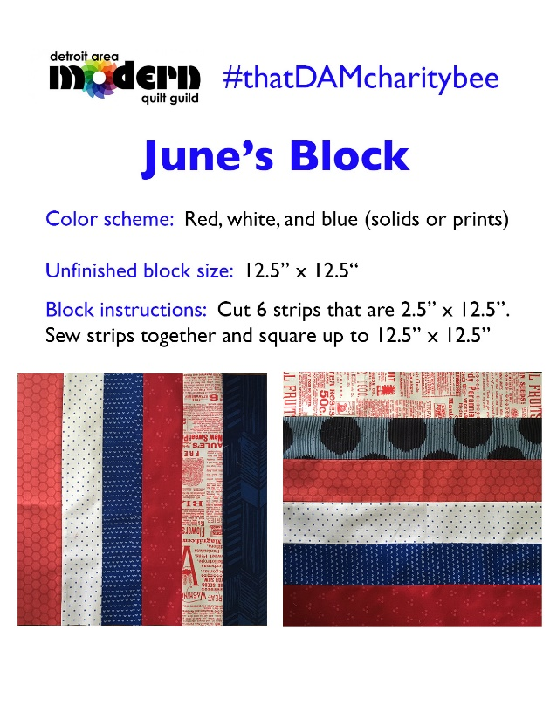
Show and Tell

Meeting adjourned at approx. 8:00pm.

Minutes provided by Lynette Holliday 2016 DAMQG Secretary

